**DOCKER AND KUBERNETES**

|  |  |
| --- | --- |
| Date | 20 November2022 |
| Student Name | SUSMITHA S |
| Roll Number | 714519104028 |
| Team ID | PNT2022TMID43211 |
| Maximum Marks | 2Marks |

# Question1:

Pull an Image from docker hub and run it in docker playground.

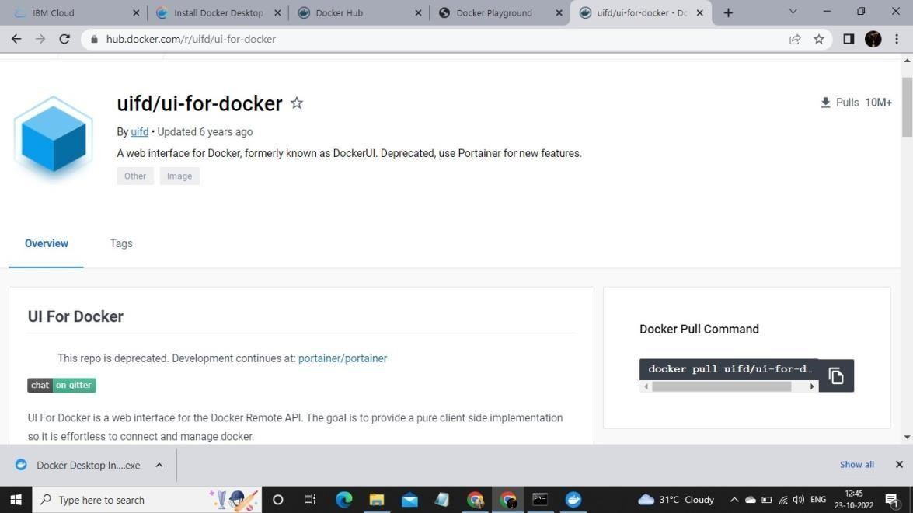

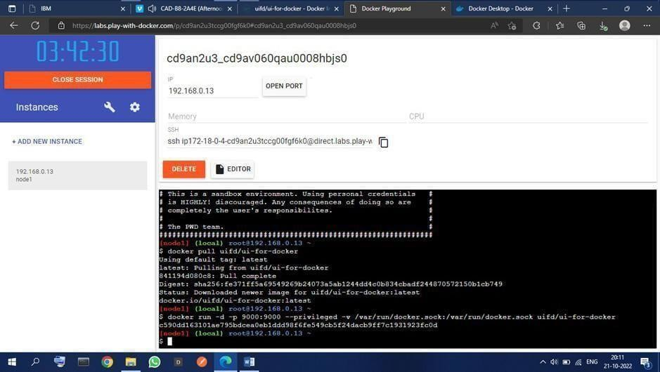

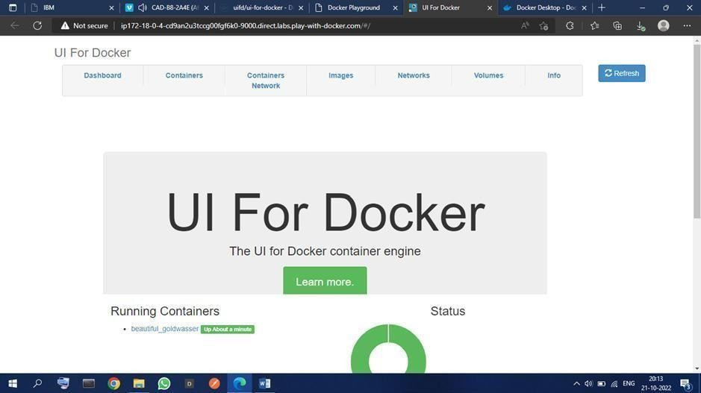

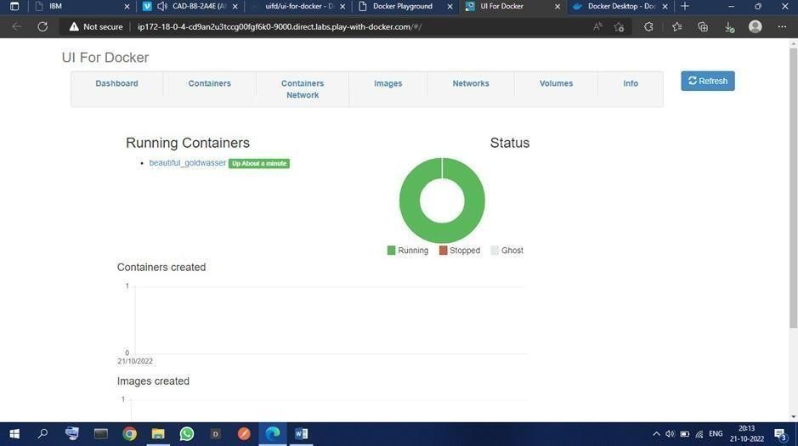

# Question2:

Create a docker file for the job portal application and deploy it in Docker Desktop Application

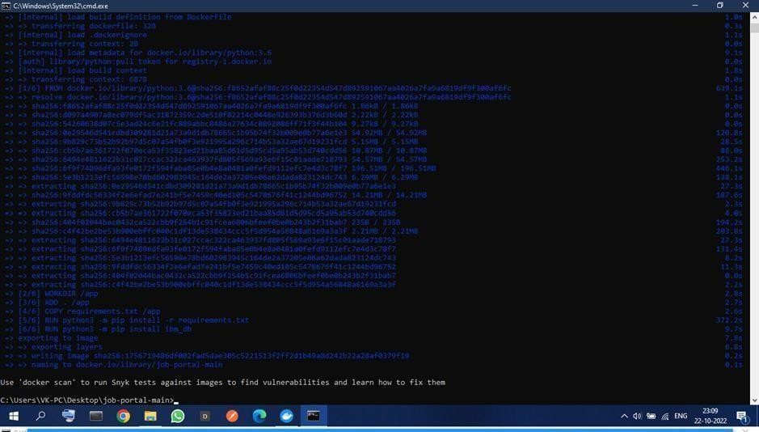

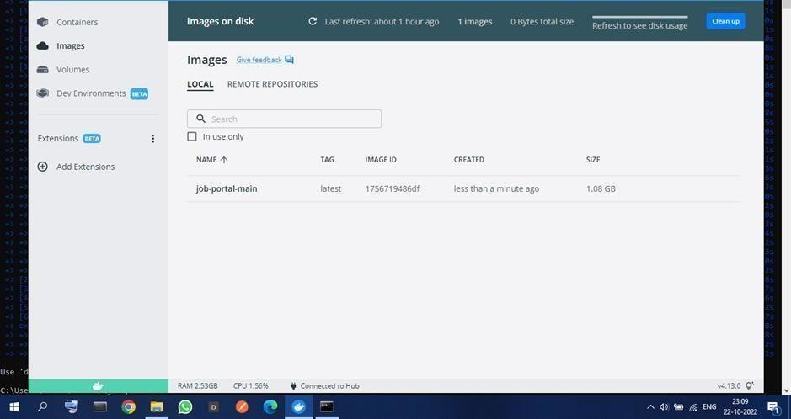

# Question3:

**Create an IBM container registry and deploy helloworld app or Job portal app.**

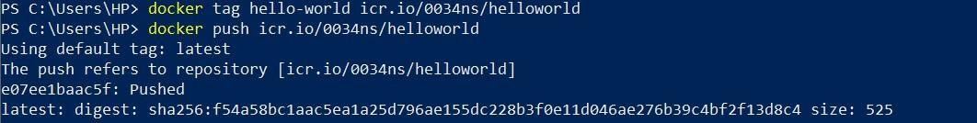

# Question4:

Create a Kubernetes cluster in IBM cloud and deploy helloworld image or job portal image and also expose the same app to run in no deport.

